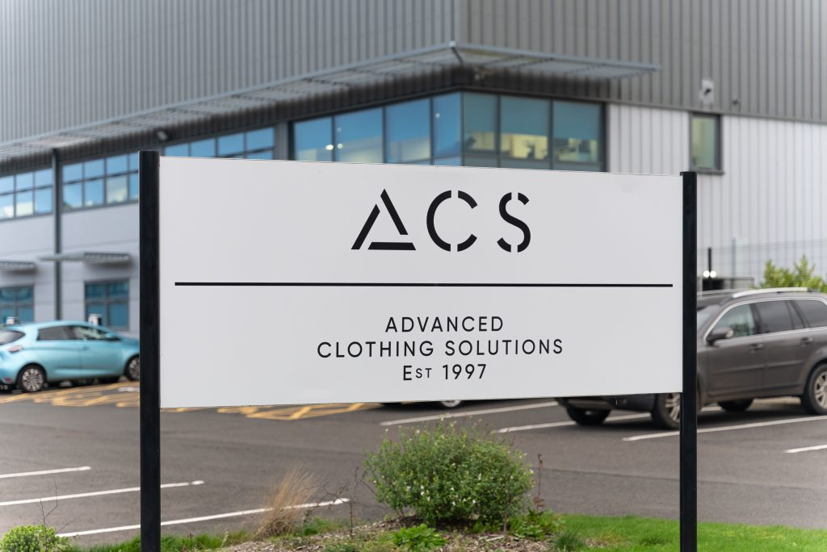

Keshav Krishnan MSc Business Analysis and Consulting

ACS Clothing

Client Report: Scope 3 Emission Saving Analysis

12 August 2024

image source: acsclothing.com



Signed Statement  
  
*Except where explicitly stated, all the work in this dissertation – including any appendices – is my own and was carried out by me during my MSc course. It has not been submitted for assessment in any other context.*

*Signed:*



# Executive Summary

ACS Clothing (hereafter referred to as ACS) is a leading innovator in the fashion industry, specialising in the renewal and redistribution of pre-owned and rental clothing. Founded with the mission to embed sustainability at the core of how the world approaches fashion, ACS operates within the framework of the circular economy; significantly reducing waste, lowering carbon emissions from clothing production, and extending the lifespan of garments. As a certified B Corporation with a notably high score, ACS is committed to applying these sustainability principles throughout its entire operations, minimising its environmental impact at every level.

As part of this endeavour, ACS has a strong focus on reducing carbon emissions, not just from direct operations but also from indirect sources. However, ‘Scope 3’ emissions, coming from sources not owned or controlled by ACS, have been comparatively difficult to manage. Despite well-designed initiatives to encourage more sustainable travel, commuter emissions have continued to rise, becoming one of the top five emission sources for ACS. With significant reductions already achieved in Scope 1 and 2 emissions, Scope 3 now presents the greatest opportunity for further environmental impact. Addressing these emissions is essential for ACS to continue progressing in its commitment to innovation and sustainability. This report aims to help manage ACS's high Scope 3 emissions by investigating the problem of high commuter emissions.

The central question addressed in this report is: ‘How should ACS Clothing reduce its high commuter emissions?’ To manage this issue, the CAUSE framework was employed to break down the problem into its core components, incorporating stakeholder insights, the management of uncertainties and external factors. The report evaluates potential solutions using Multi-Criterion Decision Analysis (MCDA), a method that accounts for the value judgments of stakeholders to identify a course of action that represents the most utility, with regards to the criteria used to assess it. The MCDA model was developed using data from employee focus groups, discussions with ACS’s Head of Sustainability, external research, and survey data provided by ACS. The goal of this report is to recommend effective interventions that ACS should consider to significantly reduce its Scope 3 commuter emissions.

The MCDA analysis found that introducing behavioural nudges, such as implementing an app to gamify sustainable practices for employees, scored the highest for the weighted criteria. Nudges offer low financial cost, ease of implementation, and strong monitoring capabilities, making it a highly feasible solution for ACS. Sensitivity analysis revealed that small adjustments in the weighting of key factors, such as employee acceptance and financial cost, could cause 'formal car-sharing help' to outrank the behavioural nudges approach. This suggests that it is important to consider both solutions as complementary interventions.

A few recommendations were made in this report. Firstly should pursue the high performing interventions by refining them through a second round of MCDA to achieve greater specificity in what type of nudges to consider. A more granular version of this intervention could allow the creation of more detailed implementation plans, which could be tested and iterated upon through close monitoring and fine-tuning based on feedback data. As the interventions suggested by the MCDA were inexpensive and relatively low-risk, this would be an effective way to gradually move towards the ‘optimal’ implementation of the interventions.

In conclusion, this report highlights that addressing ACS's Scope 3 commuter emissions requires a dual approach, focusing on both behavioural nudges and formal car-sharing help. To make meaningful progress, ACS should refine and implement these interventions with detailed plans, ongoing testing, and an alignment with the company’s broader sustainability goals. With sustained effort, ACS can make significant strides in reducing commuter emissions and continue its leadership in sustainable practices within the fashion industry.

# Acknowledgements

I wish to thank my friends in and outside Strathclyde for their valuable discussions and perspectives, which greatly enriched my work. Having spent a lot of time together, they understood how I think and supported me even when they were busy with their own projects or jobs.

I would like to extend my heartfelt gratitude to my supervisor, Dr Hanane El Raoui, for her guidance throughout this project. Her willingness to help resolve the many moments of confusion I had at the beginning of this project was so helpful in guiding my decisions. She was helpful in finding the root of the problem, even when I did not see it clearly myself.

A special thank you to Michael Cusack, the Head of Sustainability at ACS Clothing, for his time and insightful contributions. His deep knowledge and insight into sustainability were crucial in finding direction for this project. Additionally, I am grateful to Andrew at ACS for facilitating the focus groups and to all the ACS Clothing members who participated. Their candidness and cooperation were vital in gathering the necessary data, without which my project could not exist.

# Contents

Executive Summary 3

Acknowledgements 5

Contents 6

Introduction 8

Purpose of the Report: 8

Background 9

B Corp Certification 9

Scope 9

Methodology 10

Multi-Criterion Decision Analysis 10

CAUSE Framework 11

Objective of MCDA 10

Plan for Developing the MCDA Model 10

Focus Groups 11

Procedure 12

Secondary Data 12

Ethical Considerations 12

Problem Structuring: CAUSE framework (1) 14

1: Stakeholder Management (Power-Interest Grid) 14

2: Managing Uncertainties 15

2: External Factors (PESTLE Analysis) 16

Data Analysis 17

Focus Group Findings 17

Key Challenges 17

Quantitative Data Analysis 18

Transport Usage 18

Key Insight 18

Geographical Analysis 19

Key Insight 19

Problem Structuring: CAUSE framework (2) 20

4: Alternatives (Strategic Alignment) 20

Provide Formal Car-Sharing Support 21

5: Criteria (Value Tree) 21

Completing the MCDA Model 23

Scoring Alternatives 23

Bisection Method to Score Alternatives 23

Key Insights from Scored Alternatives 24

Weighting Criteria 25

Calculating the Overall Ranking 25

Interpretation of Results 26

Sensitivity Analysis 27

Conclusion 27

Discussion and Evaluation 28

Recommendations and Further Considerations 28

References 29

Appendices 30

Appendix A: PESTLE table for External Factor Analysis 30

Appendix B: Mind-map providing an overview of the CAUSE framework for this problem. 30

Appendix C: Summary Of Responses during Focus Group 31

Appendix D: Emissions and Travel Distance Data by Mode of Transport Taken 32

Appendix E: Transport Mode Patterns in Geographical Data 33

Appendix F-1: Table of Notes for Scoring Alternatives 34

Appendix F-2: Table of Linear Scores 35

Appendix F-3: Swing-Weights Table 35

Appendix F-4: Table of Scores and Weights 36

Appendix G: Bisection Curves for each Criterion 36

# Introduction

As a sustainability-driven company at the forefront of the circular clothing economy, ACS Clothing (hereby referred to as ACS) places a high priority on environmental stewardship. This commitment not only places ACS as a leader in sustainability but also enhances its reputation as an innovative and responsible partner for its clients.

To assess and improve its environmental impact, ACS actively monitors its performance through the ‘B Corp Impact Assessment’, a tool that evaluates companies across five impact areas. ACS has excelled in this assessment, achieving an impressive score of 150.9, well above the minimum threshold of 80 required for B Corp certification[1]. While improving this score further is not essential for attracting clients (given ACS's established position in circular fashion), the assessment serves as a valuable tool for identifying areas for improvement.

ACS has successfully addressed nearly all the gaps identified by the B Corp Impact Assessment from last year, implementing a wide range of sustainability measures. For example, waste heat from dry-cleaning machinery is repurposed to heat water for laundry, and biogas is used to minimise the environmental impact of burning fuel. Despite these efforts, there are limits to what can be achieved within Scope 1 and 2 emissions, which have already been effectively managed.

Given the success in managing Scope 1 and 2 emissions, ACS's focus has shifted further towards Scope 3 emissions, which accounted for over 99% of the company’s CO2 emissions in 2023[2]. While Scope 3 emissions offer significant opportunities for reduction, they are also the most challenging to manage. Among these, commuter emissions—generated from employee travel to and from ACS's logistics centre at Maxim Park—have been a growing concern. In 2024, commuter emissions emerged as a top 5 emission source, having increased by 51% (or 58.2 tCO2e[3]) from 2022 to 20232. As ACS continues to grow, so too will these emissions.

Despite initiatives to incentivize sustainable commuting, such as providing free lunches, free electric vehicle charging, and a salary sacrifice scheme for electric vehicles, there is still substantial potential for reducing commuter emissions further.

### ****Purpose of the Report:****

This report aims to support ACS Clothing in its goal of reducing Scope 3 emissions from commuter travel through problem structuring and strategic decision-making, leveraging management science techniques. It will evaluate various courses of action and propose a preliminary strategy to address the challenge of high commuter emissions.

## Background

### B Corp Certification

B Corp certification is a prestigious designation awarded to companies that meet rigorous standards of social and environmental performance, accountability, and transparency[4]. Within the ‘environment’ impact area section of the B Corp ‘impact assessment’ is the issue of emissions[5]. ACS Clothing have already made significant progress in minimizing its environmental impact by reducing Scope 1 and Scope 2 emissions. Consequently scope 3 emissions became relatively more significant for ACS, taking up 99.95% of all carbon emissions (2023)[6].

Within the B Corp Impact Assessment, commuter emissions are evaluated based on the actions a company takes to promote sustainable travel. ACS have already achieved full marks in this area, scoring 0.59/0.59. However, the impact assessment focusses on action taken by the company to encourage sustainable travel and not their effects on reducing commuter emissions. This report looks into how further strategic action could lead to greater reductions in commuter emissions.

## Scope

The scope of this report is limited to structuring the problem of high commuter emissions and performing a structured approach to determining a possible strategy to address it.

* **Problem structuring**: This report unpacks the problem to understand it from stakeholder perspectives,
* **Structured approach**: Leveraging insights from structuring and access to data, this report provides an application of decision analysis to find a strategic recommendation that could provide utility for ACS Clothing in managing the commuter emissions.

# Methodology

## Multi-Criterion Decision Analysis

This report employs Multi-Criterion Decision Analysis (MCDA), a strategic approach that integrates subjective preferences and objective measurements[7]. MCDA allows for the evaluation of potential strategies (referred to as ‘alternatives’) against a set of weighted criteria that reflect the decision-maker's preferences. This report achieves this by leveraging insights from problem structuring, and data collected through focus groups of employees and provided by ACS. Discussions with the acting decision-maker (ACS’ Head of Sustainability) helped align the decision-making process and guided the weighting of these criteria.

### Objective of MCDA

The goal of this methodology is to identify a course of action or intervention to prioritise among those outlined in the report. While this may not represent the optimal strategy due to project and model constraints, building the model will offer ACS valuable insights and a recommended strategy for further development, evaluation, and refinement. The MCDA process also allows for problem analysis and collaboration with the decision-maker to assess the current situation.

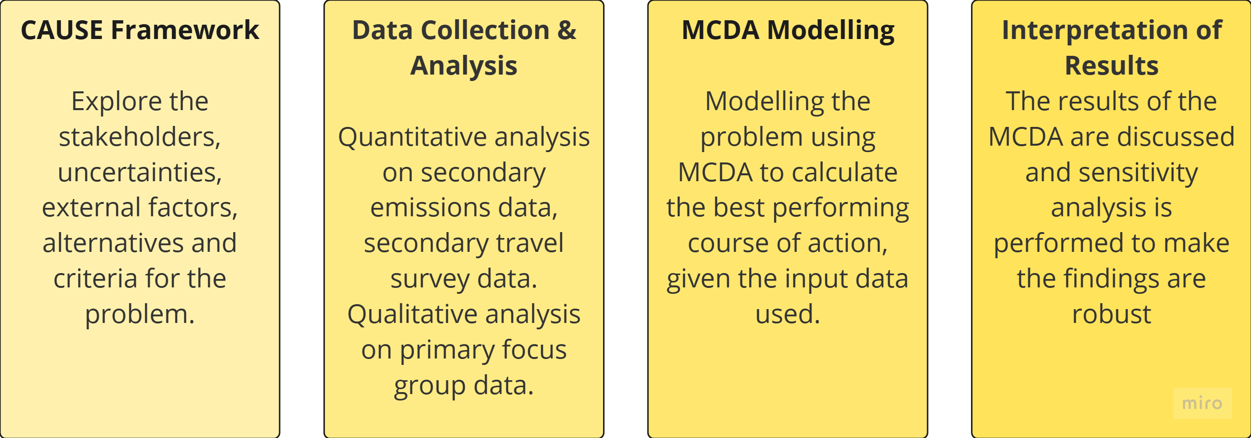

Figure 1:Stages of Methodology

### Plan for Developing the MCDA Model

The MCDA model structure, informed by prior stages, aims to guide decision-makers toward an effective solution for reducing commuter emissions while aligning with their preferences. The plan (see Figure 2) outlines how the CAUSE framework and stakeholder engagement were planned to shape the development of the model.

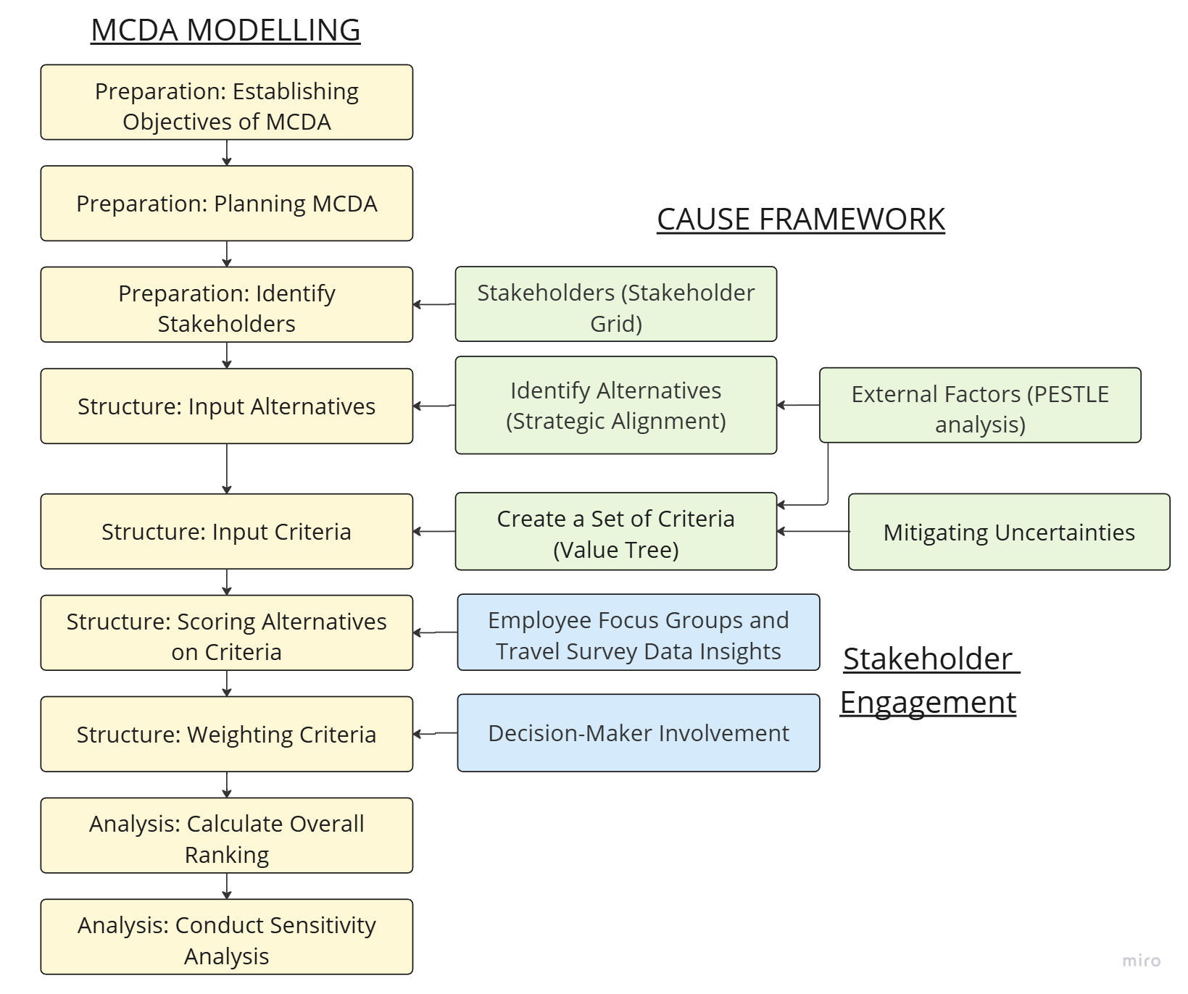

Figure : Flowchart plan for how the MCDA Model was built[8]

### CAUSE Framework

The methodology (see Figure 1) follows the CAUSE framework[9], which divides the problem into five components. The first three components—stakeholders, uncertainties, and external factors—will guide data collection and analysis, inform candidate alternatives, and establish evaluation criteria. Stakeholders will be identified and organized by their relative power and interest in the problem, which will shape how they are engaged throughout the project. Uncertainties will be addressed through mitigation strategies, including their incorporation into evaluation criteria. Key external factors will be analysed for potential opportunities that alternatives can exploit.

Insights from these three stages will inform how each alternative is scored against the criteria. Alternatives and criteria will be formalised through focus group sessions with ACS employees and analysis of travel survey data. A strategic alignment diagram will ensure that all alternatives contribute to reducing scope 3 emissions. Organising candidate criteria into a value tree will produce a measurable and relevant set of factors for evaluating alternatives.

## Focus Groups

At the start of the project, it became clear that engaging employees was essential to understand their perspectives and why they choose not to use sustainable transport options. Focus groups were organised to gain qualitative insights into the challenges of sustainable travel and identify initiatives that could most influence their decisions. These insights were further explored using historical travel survey data.

### Procedure

Three focus groups were conducted at ACS’ logistics centre, each with approximately eight employees from various departments, representing different levels of seniority and pay. Sessions lasted 15 minutes each and were facilitated with the client's support.

1. Participants were informed about the project, signed participation sheets, and gave consent to be recorded.
2. A series of planned questions were asked, with follow-ups to participants’ answers asked where as needed. Participants were encouraged to speak freely, except when clarifications were necessary, or the topic shifter away from the scope of this project.
3. After the focus groups were completed, recordings were transcribed, and summaries of the discussions were created (see Appendix C for a summary of topics and responses).

Data collected from these sessions provided qualitative insights into employee perspectives on commuting emissions, sustainable travel options, and transport preferences.

## Secondary Data

Quantitative data analysis relied on secondary data provided by ACS. This included cleaning the data to ensure consistency, converting postcodes to coordinates for easier analysis in Tableau[10], and removing any excess or personally identifiable information.

The secondary data consisted of employee transport surveys[11], postcode data of employee residences, and emissions and travel distance data for the top 10 modes of transport (see Appendix D). The data was analysed to provide insights into the geographical distribution of employees and their transport usage patterns, helping to further explore findings from the focus groups and better understand the current state of the problem.

These insights informed the development of alternatives and criteria for the MCDA model.

### Ethical Considerations

Conducting the focus groups and handling secondary employee data involved several ethical considerations to ensure the integrity and ethical soundness of this project:

1. **Confidentiality**: All participants were assured that their identities and responses would remain confidential. Personal data was anonymised to protect privacy.
2. **Voluntary Participation**: Participation in focus groups was voluntary. Employees were informed of their right to withdraw at any point without consequence.
3. **Informed Consent**: Prior to beginning discussion, participants were provided with detailed information about the purpose of the focus groups, how the data would be used, and what to expect during the sessions. Informed consent was obtained from all participants.
4. **Transparency**: The objective and potential impact of the focus groups were communicated to participants to encourage honest and open sharing of opinions.

# Problem Structuring: CAUSE framework (1)

The CAUSE Framework sections for this project follow the order shown in figure 3. Stakeholder analysis and PESTLE analysis (examining external factors) help contextualise the problem by identifying the stakeholders and external forces that influence it. Uncertainties are defined and addressed, with strategies for mitigating them integrated into the modelling process. Finally, alternatives and criteria are introduced, informed by external research and insights from earlier stages of the CAUSE framework.

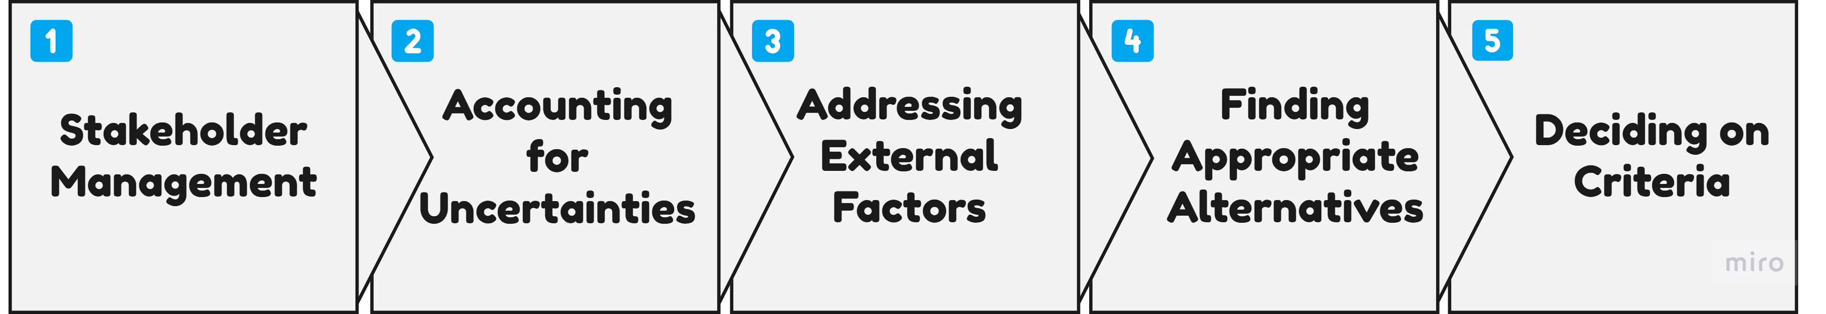

Figure : Order of CAUSE Stages for this Project.

## 1: Stakeholder Management (Power-Interest Grid)

The acting decision-maker is the Head of Sustainability who represents ACS’ interests. Stakeholders in the problem include ACS Clothing, its employees, clients, the general public, and the local government. Figure 4 represents this report’s understanding of the relative power and interests of different stakeholders with regards to the problem of high commuter emissions for ACS.

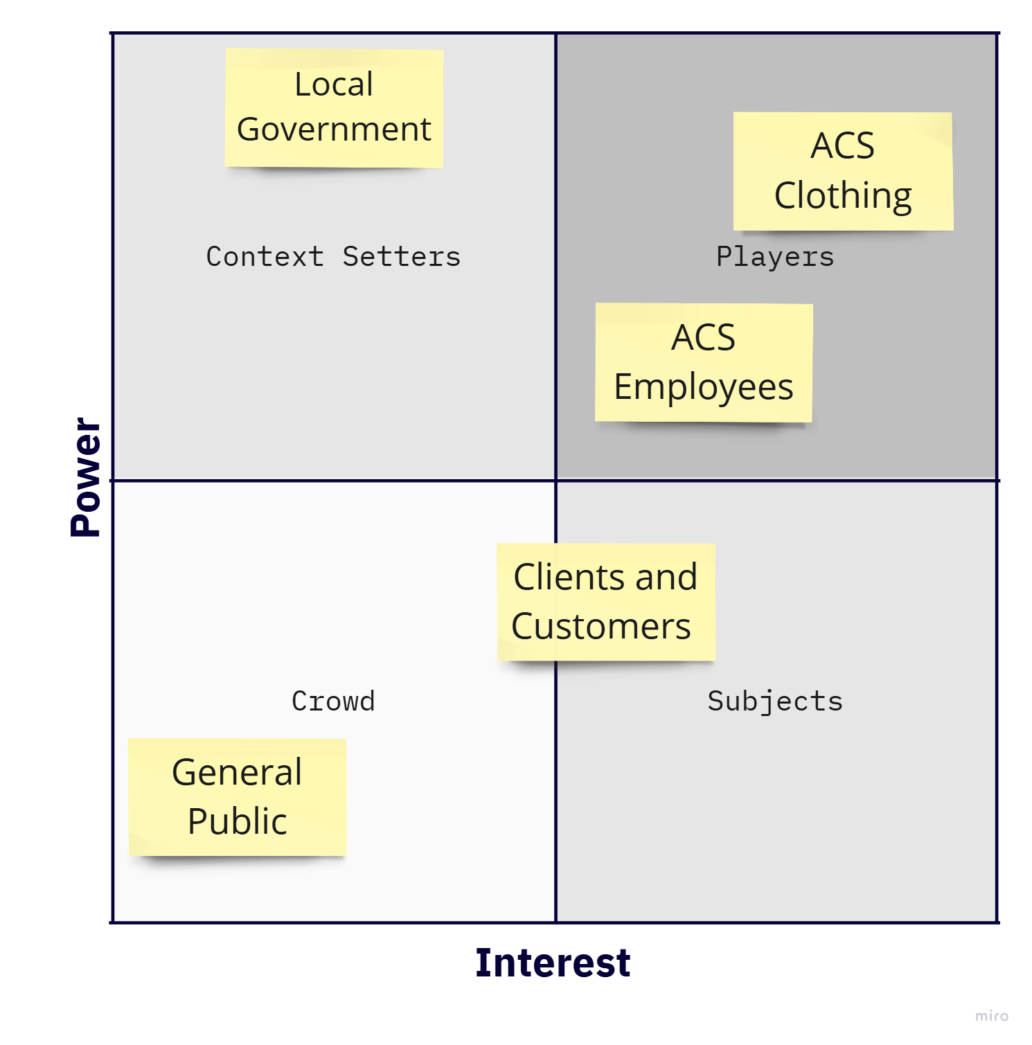

Figure : Grid showing the relative power and interest levels of various stakeholders

#### Players

In this matrix, ACS Clothing (including its managers and owners) is the primary "player," holding both high power and high interest. While ACS has the authority to implement interventions to address the problem, it has limited control over the actual impact on reducing commuter emissions. The effectiveness of these interventions depends largely on the employees, who collectively decide the success of any solution by choosing their mode of transport. However, employees have less power in the situation compared to ACS because they are not a unified entity and cannot easily coordinate their actions without external guidance.

ACS is the problem holder for this project and has the greatest interest in resolving it, as doing so aligns with their mission of promoting sustainability and strengthens their position as a leader in this space. On the other hand, employees have less direct interest in ACS's environmental goals, but they have a significant stake in the interventions themselves, as these initiatives would directly affect their commuting behaviour. As key players in this issue, ACS Clothing is engaged through ongoing discussions throughout the project, while employees are involved through focus groups during primary data collection.

#### Context Setters

The government has power over travelling infrastructure such as public transport networks, cycling infrastructure and they also determine the support given to encourage sustainable transport. The context established by this stakeholder has effectively created a system where the problem has developed, by making car use a preferable option compared to sustainable transport.

Despite having more extensive and wide-ranging power over the problem than ACS, the government is much less interested in the problem. Their interest in ACS’s commuter emissions in particular is only a small part of the wider objective to reduce emissions. As such, they act as a context setter that is unlikely to involve themselves in efforts to resolve this problem. In the future, this stakeholder might be engaged to appeal for the problem as one they should consider seriously.

#### Subjects

Companies that choose to work with ACS Clothing are probably going to be statistically more likely to consider environmental issues in their supply chain. For this problem, ACS' clients are considered to be interested in having ACS adhere to rigorous standards of environmental sustainability. As subjects to this problem, they could be kept informed about any innovations or progress towards reducing commuter emissions. This helps them in monitoring the environmental impact of partnering with ACS Clothing.

## 2: Managing Uncertainties

Much of the difficulty in attempting to resolve this problem is the high degree of uncertainty as to the actual effect of an intervention. Two key sources of uncertainty are addressed in this section.

1. **Employee Response to Intervention**: It is uncertain whether the chosen intervention will effectively reduce commuter emissions by influencing employees’ commuting behaviours. Even a well-designed intervention might not lead to significant changes, as employees may be resistant to altering their mode of transport for various reasons. Additionally, interventions may have unintended, negative side effects.

To address this uncertainty, focus groups were conducted to understand the barriers preventing employees from adopting sustainable travel and to gauge how they perceive public transport as a viable alternative. The criterion "employee acceptance" accounts for the expected effectiveness of the intervention in overcoming these barriers. To mitigate the risk of unintended side effects, the "monitoring and evaluation" criterion ensures that the intervention can be reviewed, assessed, and adjusted as needed.

1. **Uncertain Preferences**: Preferences for certain criteria may be unclear or subjective, leading to potential conflicts in decision-making. These preferences can shift over time due to external factors, such as changes in financial situations or market conditions, adding further complexity.

To manage this uncertainty, a sensitivity analysis was performed on the most uncertain criteria. This analysis demonstrates how robust the recommended intervention is by examining its performance across a range of possible weightings for a given criterion, ensuring that it remains effective under changing preferences.

## 2: External Factors (PESTLE Analysis)

To account for the external factors influencing the problem and the effectiveness of interventions, this report considers PESTLE factors (see Appendix A for the PESTLE table). From this analysis, several key factors were selected for further examination.

* Employees may avoid public transport due to the high costs of bus fares and train tickets, especially those who require multiple bus routes to reach work.
* The quality and accessibility of local transport infrastructure significantly impact commuting choices. Poor public transport links, limited cycling paths, and inadequate pedestrian infrastructure restrict sustainable travel options.

High public transport costs and poor infrastructure are key limiting factors for the effectiveness or of any alternative that does not offer a way around them. The criterion, ‘environmental impact’ will consider how an alternative shifts the environment of travel.

* Cultural perceptions around car ownership, public transport, and environmental sustainability also influence employee behaviour. For example, there may be a long-standing belief that bus travel is unreliable, or that using a car is essential.

An intervention that effectively challenges these perceptions could encourage employees to view public transport more positively in the long term. The previously mentioned criterion, ‘employee acceptance’ will be adapted to include this psychological aspect of managing commuter emissions.

# Data Analysis

Prior to the final 2 stages of the CAUSE framework (identifying alternatives and criteria), insights from data analysis are presented in this section. From these insights, alternatives are developed that either address a key underlying challenge to the adoption of public transport or target an opportunity that has been identified.

## Focus Group Findings

The focus group discussions helped verify several assumptions about why employees prefer using cars.

1. **Convenience**: Cars are perceived as the most convenient mode of transport.
2. **Slow Public Transport**: Public transport is considered slow compared to driving.
3. **Poor Public Transport Links**: Many employees live in areas with inadequate public transport links.
4. **Cost**: Public transport is perceived as more expensive than driving.
5. **Physical Effort**: Traveling by human power (e.g., biking or walking) is seen as too difficult and inappropriate for most employees.
6. **Car Sharing Concerns**: Car sharing is viewed as potentially dangerous, and employees often do not know anyone to share with.
7. **Lack of Environmental Concerns**: Even among those who do not use a car, that decision is not driven by environmental concerns.
8. **Lack of Space to Relax**: Besides the canteen, there is a lack of space dedicated to relaxing while not on a shift. This can make the waiting time between arriving at work, the shift, and leaving work feel worse.
9. **Multi-layered Problems with sustainable transport**: When asked, employees stated that they could not identify any one key factor behind their use of a car.

### Key Challenges

**Low Consideration for Sustainability**: Employees do not significantly value environmental impact when choosing their mode of transport. Aligning employees with ACS’ values for the environment could be a powerful way to improve employee engagement with sustainability efforts.

**Inherent Benefits of Car Travel**: The perceived benefits of car travel, such as convenience, speed, and cost-effectiveness, are substantial barriers. Initiatives promoting sustainable transport could offset some of the relative shortcomings of sustainable travel to be considered more viable.

## Quantitative Data Analysis

### Transport Usage

Figure 7 shows the population of employees at ACS Clothing divided by the mode of transport used during their commute[12]. 51 employees (77% of surveyed employees) prefer to commute by car, with the only prominent competition to car-travel being that of bus travel. Other modes of transport are very unpopular, not being used by more than 1 employee each. Of the 51 car-travellers, 32 have stated that they car-share. Car sharing seems to be the most preferred form of sustainable travel for ACS employees.

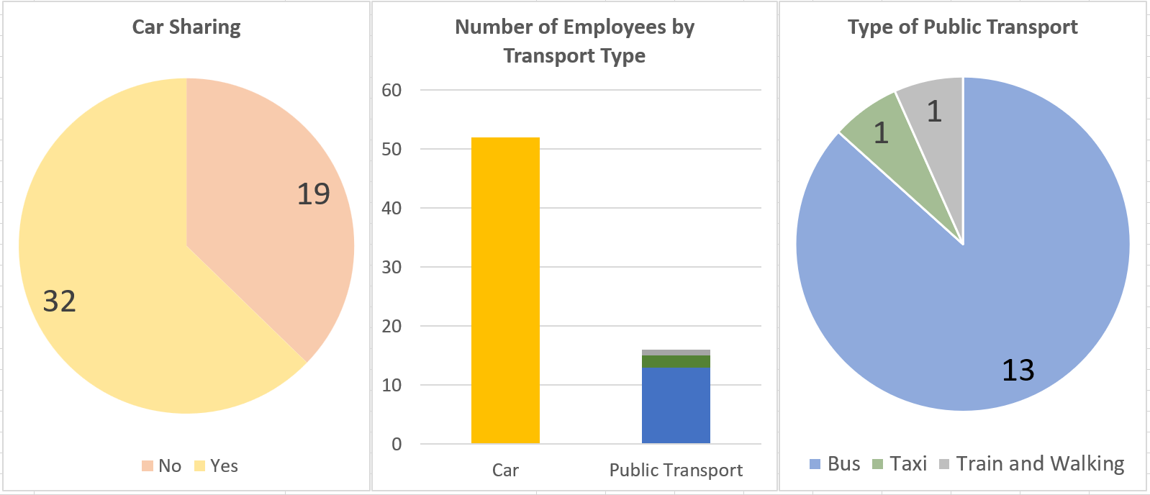

Figure : Charts showing the breakdown of employees by their chosen transport (March 2024)

### Key Insight

The high adoption of car-sharing indicates that further efforts to promote it may be unnecessary, as employees are generally already willing and able to participate in car-sharing on their own. However, car-sharing still generates significant carbon emissions for ACS (see Appendix D). If ACS focuses solely on promoting car-sharing, its potential to reduce overall carbon emissions would be limited. The trade-off is that car-sharing may be the easiest sustainable travel option to encourage, given its current popularity among employees.

The criterion of ‘environmental impact’ will assess the expected carbon reduction from each intervention, giving lower scores to interventions that promote carbon-emitting travel options. Interventions that support more sustainable, non-car modes of transport will score higher, but this must be balanced against the ‘employee acceptance’ criterion, which considers that these options may be less appealing to employees.

### Geographical Analysis

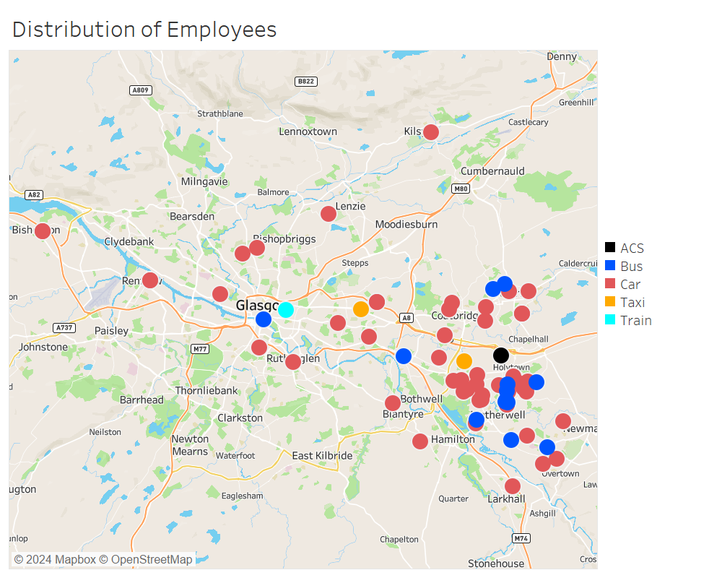

Figure :Map Showing the geographical distribution of ACS employees and their used mode of transport.

### Key Insight

The geographical distribution of employees is concentrated around ACS, with the highest density near the company (see Appendix E for more detailed insights). Employees living closer to ACS are more likely to use public transport, suggesting that shorter public transport journeys are more tolerable, while longer journeys are less preferable. This is likely due to longer public transport trips becoming more complicated and expensive as they require multiple transfers. Providing a company transport option for the areas surrounding ACS could streamline the process and encourage sustainable travel for these employees, while making it easier for car-users to choose sustainable travel.

# Problem Structuring: CAUSE framework (2)

## 4: Alternatives (Strategic Alignment)

The alternatives are placed in a simple strategic alignment map (figure 5) to show how each works towards the goal of reducing scope 3 emissions and ACS’ overall environmental impact.

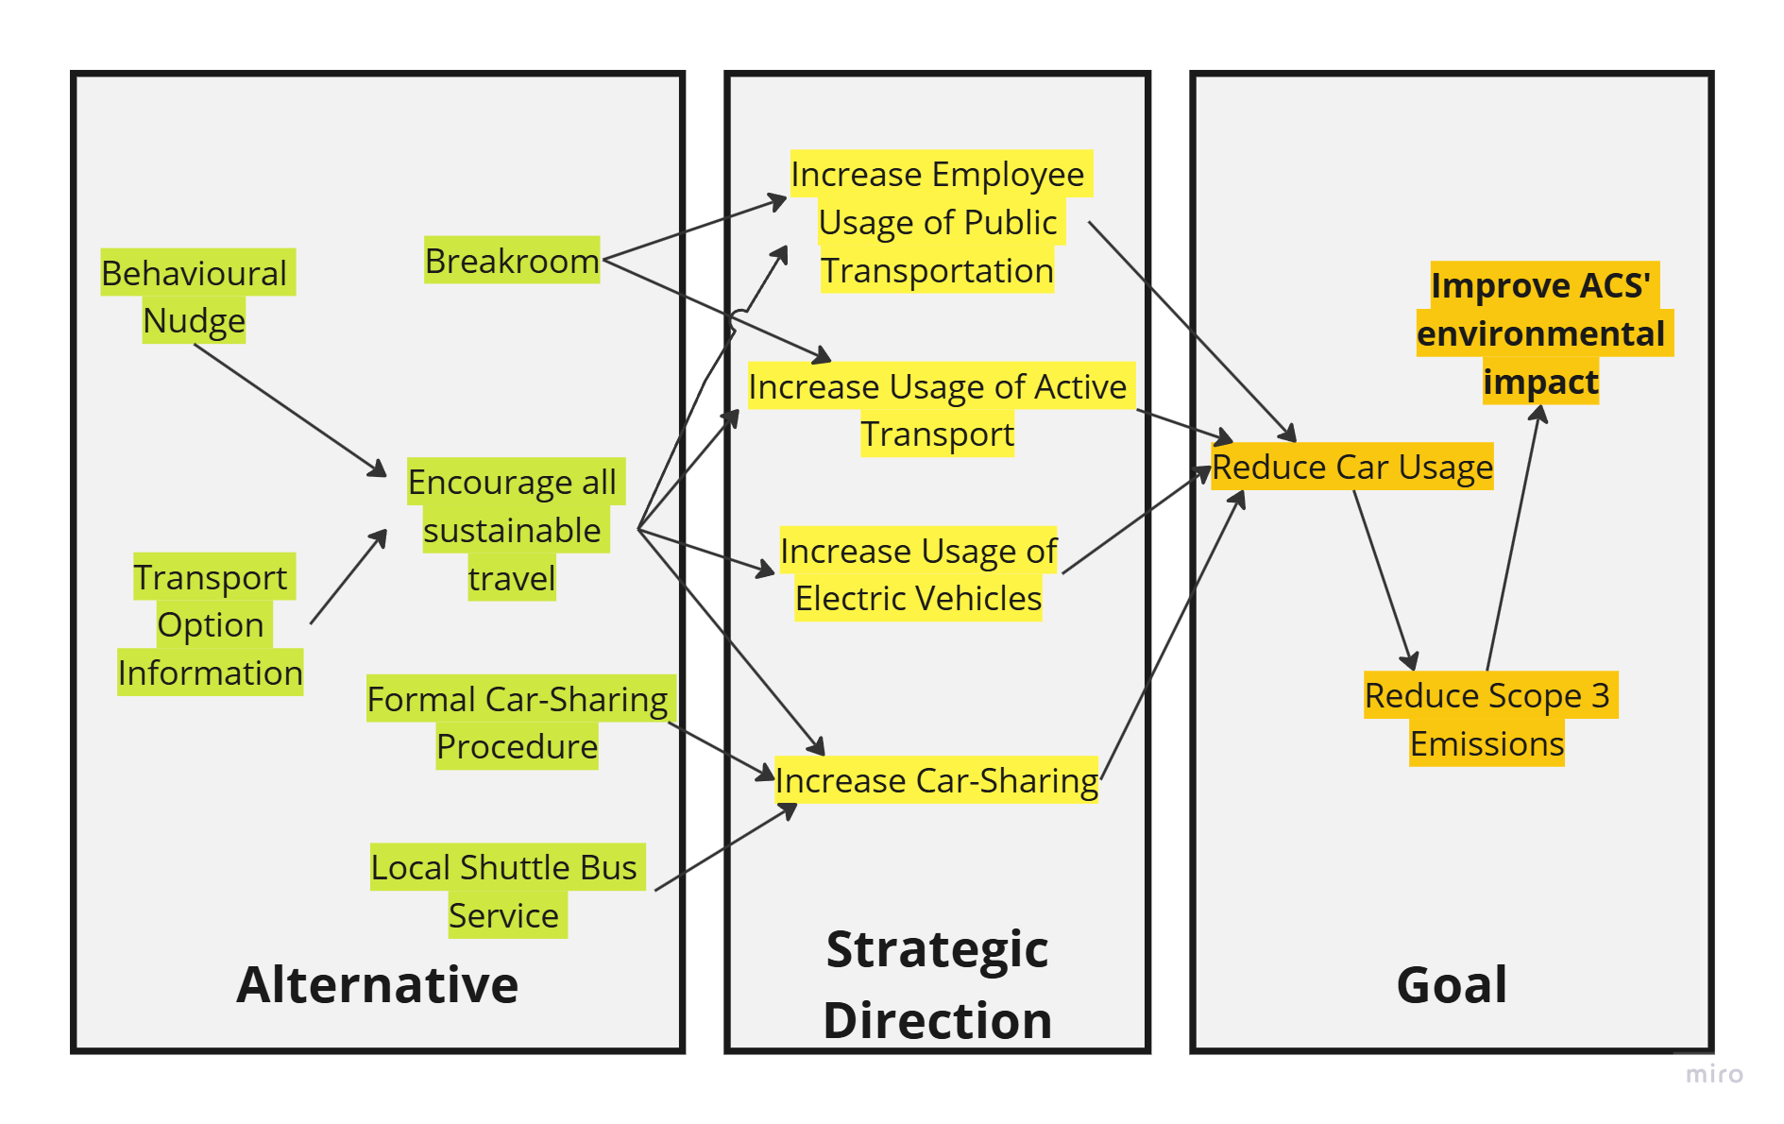

Figure : Cognitive map showing the alignment of the alternatives with ACS Clothing's goal

#### Behavioural Nudges: Emissions Gamification

To encourage sustainable travel, ACS could introduce a dedicated app to gamify emissions reduction. By leveraging behavioural nudges, the app would encourage employees to choose sustainable transport options through goal-setting, friendly competition, and personal growth tracking. For example, employees could set personal sustainability goals—such as reducing their carbon footprint or increasing their use of public transport—and track their progress in real-time.

The app could include features like leaderboards, where employees compete for recognition and rewards, or personalized challenges, such as "walk or bike to work 10 times this month." Small incentives could be used to encourage employees to get into the habit of using the app. By aligning with ACS’s sustainability goals, this app could make eco-friendly travel both engaging and rewarding for employees.[13]

#### Improve Amenities: Lounge Area

Providing a well-equipped lounge area for employees to use while waiting for their shift or for public transport could significantly improve the commuting experience, especially when shift times and public transport schedules don't perfectly align. Offering refreshments and a comfortable space to relax at the start or end of a commute taps into the psychological principle known as the "peak-end rule." This cognitive heuristic makes it so that people judge an experience largely based on how they feel at its most intense point (the peak) and at its conclusion (the end)[14]. By enhancing these moments with positive elements, ACS could help create more positive memories of the overall commute. This, in turn, may reduce the social stigma around using non-car transport options by associating sustainable travel with a more enjoyable and rewarding experience.

Provide Formal Car-Sharing Support

Although an app that facilitates car-sharing already exists for some employees, it either has not been widely distributed to employees or there is a lack of knowledge that this facility exists. ACS management could step in to actively connect workers who live in the same area and suggest that they travel together. From the travel survey data, car-sharing is clearly the most popular form of sustainable travel, and so potentially an easier option to promote successfully.

#### Improve Information Distribution of Transport Options

To address the issue of employees being unaware of available sustainable transport options, ACS could take the initiative to actively promote these choices. By providing clear and accessible travel route options, especially during the onboarding process, ACS can help employees consider sustainable commuting as a viable and attractive alternative to driving.

This could involve incorporating detailed information about public transport routes, schedules, and the benefits of sustainable travel into new hire orientations and ongoing company communications. Creating a centralized, easy-to-access resource hub for all commuting options would further enable employees to make well-informed decisions. By embedding sustainable travel information into the company culture from the outset, ACS can challenge assumptions about public transport and normalise it as a convenient, practical choice for employees.

#### Local Shuttle Service

Implementing a shuttle bus service can provide a direct, convenient, and sustainable commuting option for ACS employees. This service would operate on key routes, connecting local areas with poor public transport links to the workplace, thus reducing the reliance on personal vehicles. By coordinating the shuttle schedule with work shifts, ACS can reduce waiting times for employees and enhance the convenience of using public transport. The shuttle bus service not only helps in lowering Scope 3 emissions but also supports employees who face difficulties in accessing traditional public transport options, making it an environmentally and employee friendly solution.

## 5: Criteria (Value Tree)

The ‘value tree’ (figure 6) breaks down the problem into attributes that define the criteria by which the alternative courses of action are scored during MCDA modelling. Criteria not developed in previous sections were chosen to form a simple, relatively complete set of criteria to evaluate the relevant strengths and weaknesses of the alternatives.

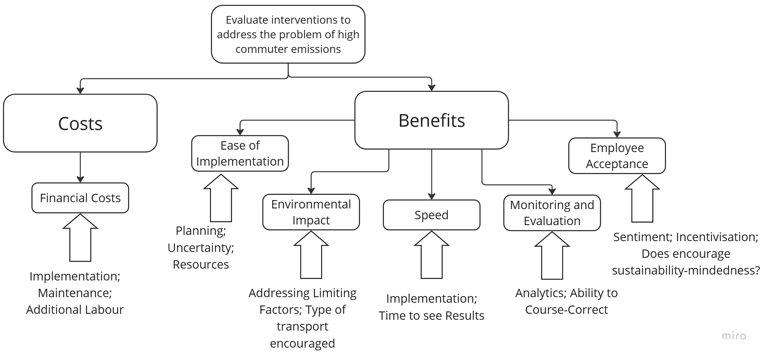

Figure : Value tree shoring criteria and some attributes with which to measure them

1. **Financial Costs**: This criterion evaluates the monetary investment needed for each intervention, ensuring that ACS balances spending with potential impact to favour the most cost-effective alternatives.
2. **Ease of Implementation**: This involves how many non-monetary resources and time is spent planning, facilitating and maintaining the intervention.
3. **Environmental Impact:** This measures the expected effectiveness of the chosen intervention in reducing carbon emissions. The more directly the intervention addresses the challenges to sustainable travel, the more impactful it would be. Interventions that promote sustainable travel with fewer emissions involved are favoured.
4. **Speed**: This accounts for the time-delays involved in implementation and the time taken to see expected results in a reduction in CO2 emissions. Short-term benefits are favoured compared to long-term benefits, assuming both benefits are equal.
5. **Monitoring and Evaluation**: This criterion accounts for how easy it is to effectively monitor the effect of the intervention to adapt it to be more effective or to avoid problems caused by an unintended side-effect.
6. **Employee Acceptance**: This criterion measures the expected engagement with the intervention by employees. This involves whether the intervention addresses any psychological barriers to using sustainable travel, and whether the intervention provides immediate value to the employee. Including employees in the MCDA model addresses the power that employees have in deciding the effectiveness of a given solution.

# Completing the MCDA Model

To complete the model, the best-performing alternative was identified, and its robustness was assessed through a sensitivity analysis. First, the alternatives were scored against the criteria using insights from data analysis and focus groups. These criteria were then shared with the decision-maker, who weighted them according to their preferences and refined them through discussion. The weighted scores were tallied to determine the top alternative.

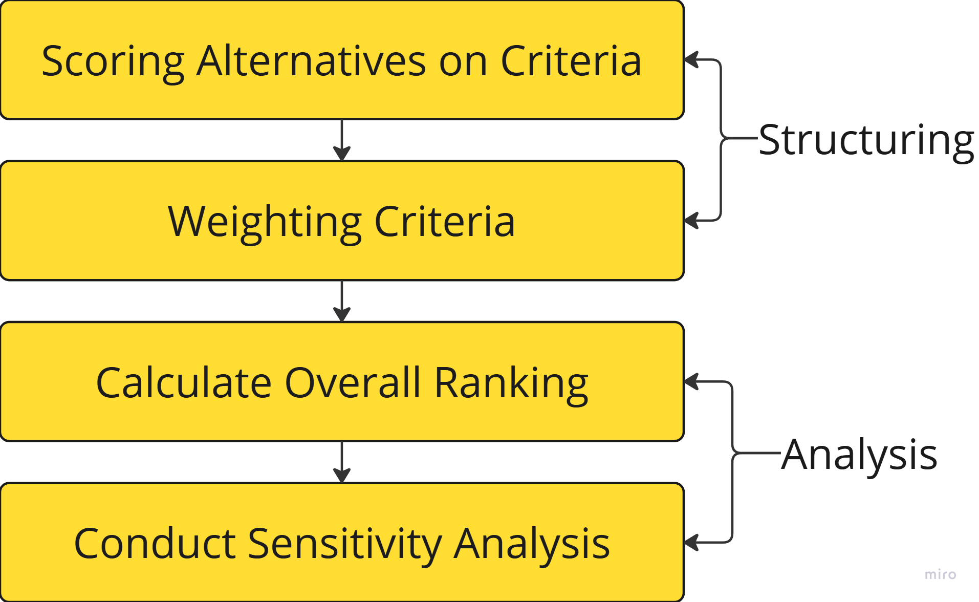

Figure : Final Stages of MCDA

## Scoring Alternatives



Table : Table of Raw Scores I (descriptions)

Table 1 rates the performance of each alternative from a scale of very low to very high for each criteria[15]. These values would be attached to a proper score by placing these descriptive performances on a linear scale (such that the lowest performance is 0, the highest is 100, and the rest are determined by relative positioning on the scale). These linear scores are then converted into actual scores using the ‘bisection method’ to account for non-linear relationships between preference and performance (e.g. where an improvement from score 0 to 10 is not equivalent to the improvement from 70 to 80).

### Bisection Method to Score Alternatives

This method involved defining the score for a midpoint performance (exactly in-between the best and worst performances in each criteria), then scoring the 25% and 75% points. This forms relationship curves for each criteria (see Appendix G). The raw score for each alternative can be converted to the numericized score using these curves. Some of the non-linear relationships are justified in this section (see Appendix F-4 for complete scores table developed through the bisection method):

The scoring for financial cost increases rapidly and slows, the lower the cost is. This is because financial costs rise to a point of unfeasibility, at which point any additional cost will be less impactful as the alternative is unlikely to be considered further. The same is true for environmental impact but in reverse. As the environmental impact of an alternative becomes increasingly attractive, the alternative reaches a point where it is already worth doing in terms of its environmental impact and any additional impact in this area has less of an impact in the decision-making process. Monitoring and evaluation achieve a similar shape as data becomes less valuable and redundant at a certain point. If there is no one to comb through and analyse the volume of data being produced, there is little point in having it.

On the other side, the easier an intervention is to implement, typically, the less planning and consideration that needs to be spent on considering it. As an intervention becomes increasingly trivial and involve less uncertainty to implement, it becomes more attractive.

### Key Insights from Scored Alternatives

The performance profile (figure 11) shows how each alternative performs across each criteria. Consistently bad performers include ‘Company Transport’ and ‘Provide Travel Information’. Consistently high performers include ‘Behavioral Nudges’ and ‘Formal Car-Sharing Help’. Each alternative has a criterion where they perform strongest, so there are trade-offs for choosing any one alternative over another.

Figure : Performance Profile of Each Alternative

### Weighting Criteria

To weight the criteria, the decision-maker was contacted to make some preliminary suggestions for the weights using the ‘swing weight’ method. In this method, each ‘swing’ or movement from one the worst to best performance in each criteria is evaluated in comparison to each other. The method asks, ‘how much more do I prefer the movement from the worst to best criteria in one criteria versus another’ (see Appendix F-3 for Swing-Weight Table). These preliminary weights were modified based on personal judgement and then the weights are normalised to add up to 1.

The decision-maker weighted FC (financial cost) as highest owing to its decisive quality in determining the feasibility of an intervention (see figure 11). EA (Employee Acceptance) is highly weighed as the effect of the intervention on employee behaviour is key to the success of an alternative.

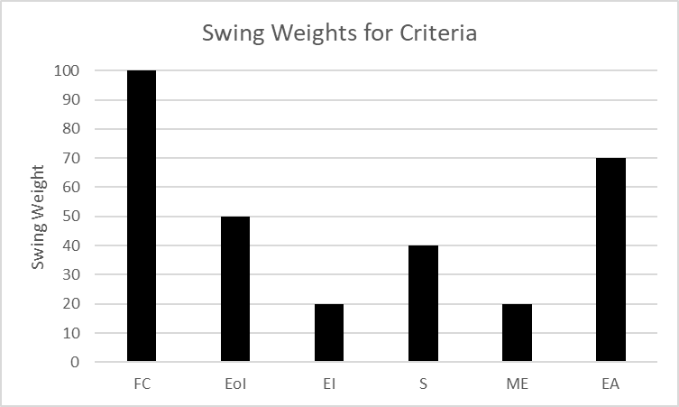

Figure : Swing Weights for each Criteria

### Calculating the Overall Ranking

By applying the normalised weight to each score and adding up the scores for each criteria and ranking them, we find the overall performance of each alternative. ‘Behavioural Nudges’ performed best, given this reports set of criteria, scoring and weights.



Table : Table of Weighted Scores, Total Scores and Ranks

### Interpretation of Results

The Multi-Criteria Decision Analysis (MCDA) reveals that **‘Behavioural Nudging’ is the most effective strategy for reducing Scope 3 emissions from employee commutes,** with a total score of 73.43. This alternative excels primarily due to its low financial cost (scoring a high 29.3), simplicity in implementation, and relatively high ‘monitoring and evaluation’ score (6.7), making it a feasible and cost-effective solution for ACS.

‘Formal Car-sharing Help’ came in at a close second with a score of 73.03, benefiting from a balance of low financial costs and moderate environmental impact (0.91), though its employee acceptance score was low (3.5).

‘Improving Amenities’ and ‘Company Transport’ rank lowest primarily due to their higher financial costs. Improving amenities, while positively received by employees and environmentally impactful, involves investment and slow results. Company transport, although highly effective environmentally, is the most costly and most difficult to implement, making it less feasible.

A Pareto efficiency frontier was drawn (Figure 12) to evaluate the relative efficiency of various alternatives. In this analysis, financial cost is inversely represented by its score value, meaning a higher score indicates a lower cost for that alternative. The chart highlights that three alternatives - behavioural nudges, formal car-sharing, and travel information - are Pareto efficient, as they lie on the Pareto curve. These options ‘dominate’ the others by offering superior benefits while having lesser costs, making them the most cost-efficient choices.

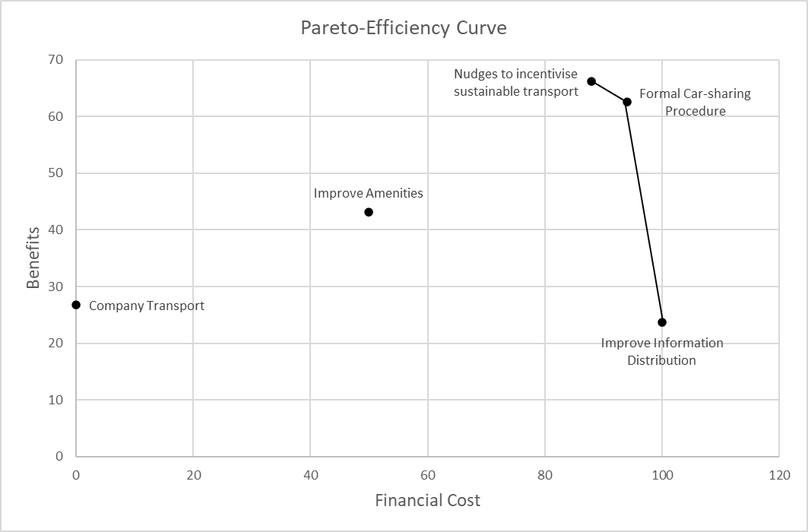

Figure : Chart showing the pareto-efficiency frontier

### Sensitivity Analysis

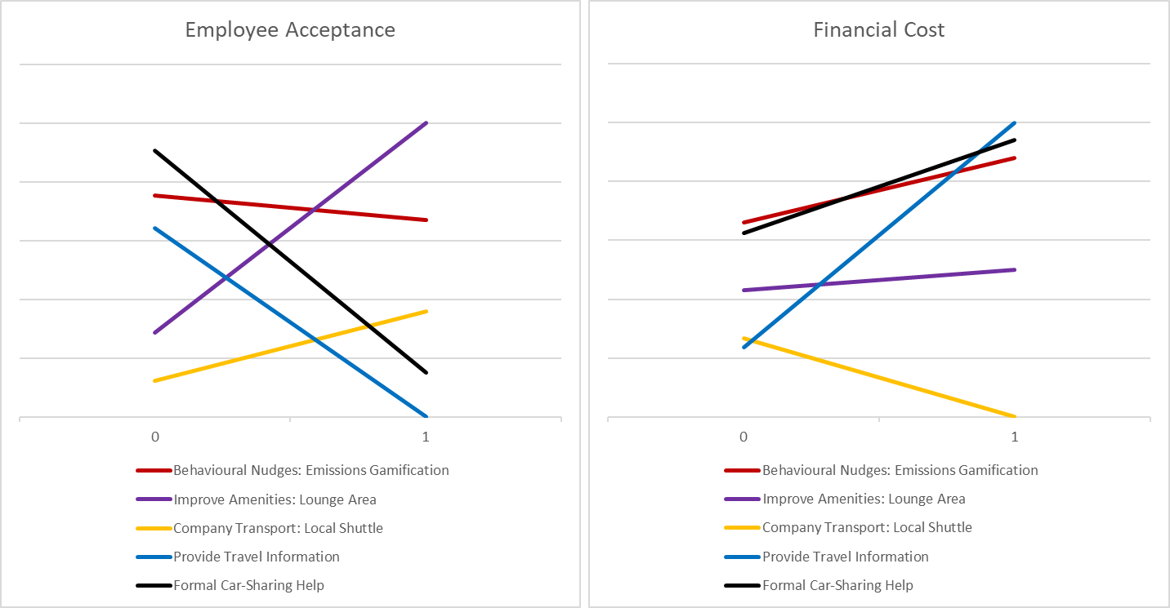

Figure : Sensitivity Analysis for Criteria: 'Employee Acceptance' and 'Financial Cost'

I chose to perform a sensitivity analysis on employee acceptance as this was a key leading factor in the compliance of employees with the given alternative and contributes heavily in deciding the overall success of that intervention. To address the problem of uncertainty in the ‘financial cost’, for which preferences may shift over time differently depending on the final situation of ACS, this criteria was also used for sensitivity analysis.

A slight adjustment in the significance assigned to either employee acceptance or financial cost would make 'provide formal car-sharing help' the top-performing alternative. Specifically, reducing the weight of employee acceptance from its current normalised value of 0.233 to 0.23, or increasing the weight of financial cost by 0.05 from its current 0.33, would elevate formal car-sharing to be the new best-performing option.

# Conclusion

The MCDA analysis suggests that introducing behavioural nudges, such as implementing an app to gamify being sustainable for employees, could be the most advantageous strategy at reducing commuter emissions for this report’s list of alternatives, the scoring, and weighted criteria. This approach leads in overall performance due to its low financial cost, ease of implementation, and solid monitoring capabilities

.

Sensitivity analysis reveals that small shifts in the weighting of key criteria (employee acceptance and financial cost), could change the rankings such that providing ‘formal car-sharing help’ would become the top performing alternative. This demonstrates the delicate balance between different decision-making factors, and because MCDA is based on a lot of subjective value judgements, it would be prudent to say that both of these alternatives perform the best together. This conclusion is pushed further by their shared high performances in the performance profile and placement on the Pareto-efficiency frontier.

As such the recommendation for this report is to pursue both behavioural nudges and formal car-sharing help further develop each intervention to determine whether they are actually viable and create a detailed plan of action to implement them effectively.

# Discussion and Evaluation

This report has several limitations that provide context on how the findings can be used for the future.

* **MCDA as a Starting Point, Not an End[16]**: While the MCDA provides a structured approach to identifying potential strategies, it does not provide an ‘optimal’ solution. The inherent subjectivity in assigning weights and evaluating criteria means that the results should be viewed as a foundation for further discussion rather than a final determination. Given the limited time and engagement with the decision-maker during this project, it is essential to revisit and refine the MCDA results through further discussion.
* **Need for Detailed Implementation Plans:** The alternatives presented in this report are broad and conceptual, lacking the granular details necessary for immediate implementation. This generality limits the decision-maker’s ability to translate recommendations into actionable steps. To move forward, these alternatives should be refined into specific, well-defined plans.
* **Consideration of ACS’s Broader Objectives:** This report focuses exclusively on addressing Scope 3 commuter emissions, a specific aspect of ACS’s operations. However, as a multifaceted organisation with various competing objectives, ACS may need to consider a more holistic approach. The recommendations provided should be weighed against ACS’s broader goals and priorities to ensure that the proposed strategies align with the company’s overall mission. A systemic review may be necessary to determine whether these narrowly focused strategies are truly beneficial within the context of ACS’s diverse objectives.

# Recommendations and Further Considerations

This report provides the following recommendations that may provide the ‘next steps’ for ACS to consider in managing the problem of high commuter emissions. These all centre around developing the insights from this report’s analysis so that they be more practical:

1. Conduct a Second Round of MCDA (or another strategic decision-making procedure) to refine the recommended alternatives down to a more granular and specific intervention. Conducting another round of MCDA would be beneficial in evaluating different versions of each recommended intervention, finding a best performing version of that alternative. This should also be conducted with greater involvement with ACS’ decision-making staff.
2. Create a Detailed Implementation Plan for both alternatives emerging from this report’s MCDA. For the behavioural nudges app, market research could be conducted first to understand which technology and implementation plan has worked well for other companies with similar issue.
3. Repeatedly Test and Iterate on Interventions**.** For alternatives like formal car-sharing help where the cost of implementation is fairly low, this intervention could be trialled to find out whether it is getting the intended response. With close monitoring and fine-tuning, the process of trial-and-error could improve on the initial implementation to maximise the effectiveness of that intervention.

--------------------------------------------------------------------------------------------------------------------------

Thank you very much for reading this report!

# References

B Corporation, 2024. *ACS Clothing Ltd..*

[Online]   
Available at: https://www.bcorporation.net/en-us/find-a-b-corp/company/acs-clothing-ltd/

B Corporation, 2024. *Measuring a company’s entire social and environmental impact..*

[Online]   
Available at:

https://www.bcorporation.net/en-us/certification/  
[Accessed 3 8 2024].

Daniel Kahneman, B. L. F. C. A. S. D. A. R., 1993. When More Pain Is Preferred to Less: Adding a Better End. *Psychological Science,* 4(6), pp. 401-405.

Drach, G., 2024. *tps.org.uk.*

[Online]   
Available at: https://tps.org.uk/public/downloads/Y6wZs/The%20Use%20of%20gamification%20to%20increase%20sustainable%20travel%20behaviour,%20Greg%20Drach.pdf

University of Strathclyde, 2024. *MCDA Overview and Example: Multi-attribute value analysis.* [Online]   
Available at: Accessable on myplace for MS921

# Appendices

## Appendix A: PESTLE table for External Factor Analysis

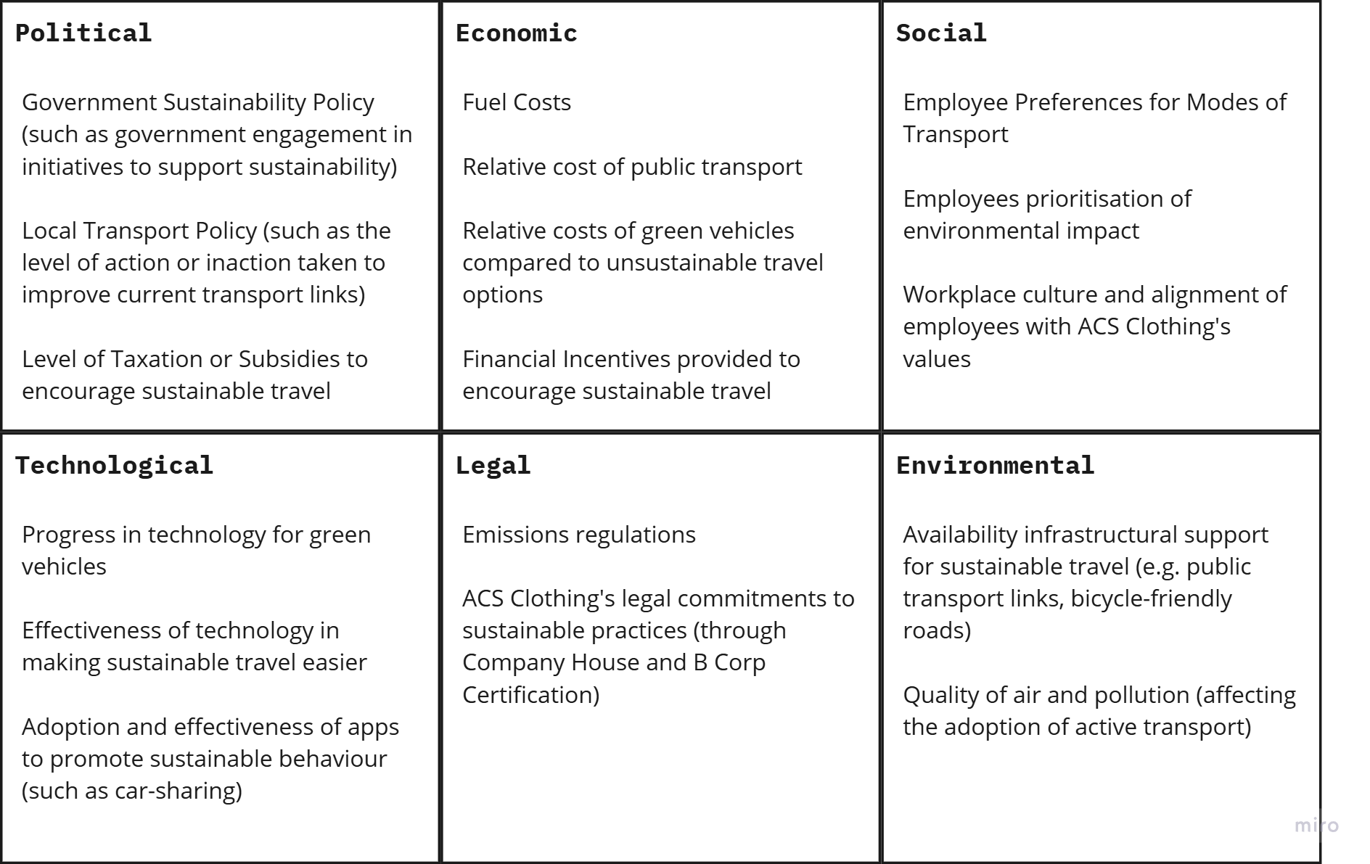

## Appendix B: Mind-map providing an overview of the CAUSE framework for this problem.

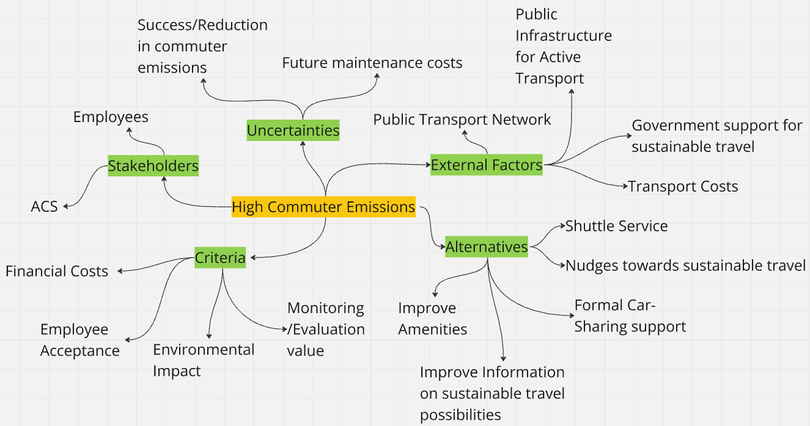

## Appendix C: Summary Of Responses during Focus Group

|  |  |
| --- | --- |
| Topic | Summary of responses |
| Mode of travel to and from work | The vast majority travel by car. The only two participants in the focus group who travelled by bus also would travel by car when it would be available to them. One participant used an electric bike, alongside using the bus or train to work. |
| Car Sharing | Many participants said that they car share. Those that did not were open to the idea of car sharing, especially with people they know in the same teams within ACS Clothing. Some people were willing to share their car, but unwilling to use someone else’s.  The reasons for car-sharing are typically to save on money, effort in driving (as journeys are similar), because one party does not have a car, and finally for company on the way to and from ACS Clothing. |
| Why cars are preferred | Cars are by far the most convenient.  Public transport options are often far worse in terms of time investment and cost. Some participants felt that it would be uncomfortable to take public transport  Driving in a car is less stressful and provides more freedom and reliability. |
| Problems with Public Transport Links | In many cases, participants do not have access to easy public transport in the local area. Where they do, they transport options do not offer an easy and fast way to ACS Clothing.  Even when these links exist, often the bus schedule starts after participants’ shifts (often starting early at 6am or 7am) |
| Prioritisation of environmental impact in daily life | The vast majority of participants stated that they do not consider their environmental impact.  For the one participant who stated that they do care about this issue, they also stated that they do not value sustainability when considering their chosen mode of transport for a commute. |
| Knowledge of ACS schemes to encourage sustainable travel | Many participants were aware of the free lunch scheme for travelling to work sustainably. |
| What would need to change to make you consider public transport? | No participant had an idea of how to make public transport more attractive to them. Some stated that there were many problems that work together to public transport not a considered option. |

## Appendix D: Emissions and Travel Distance Data by Mode of Transport Taken

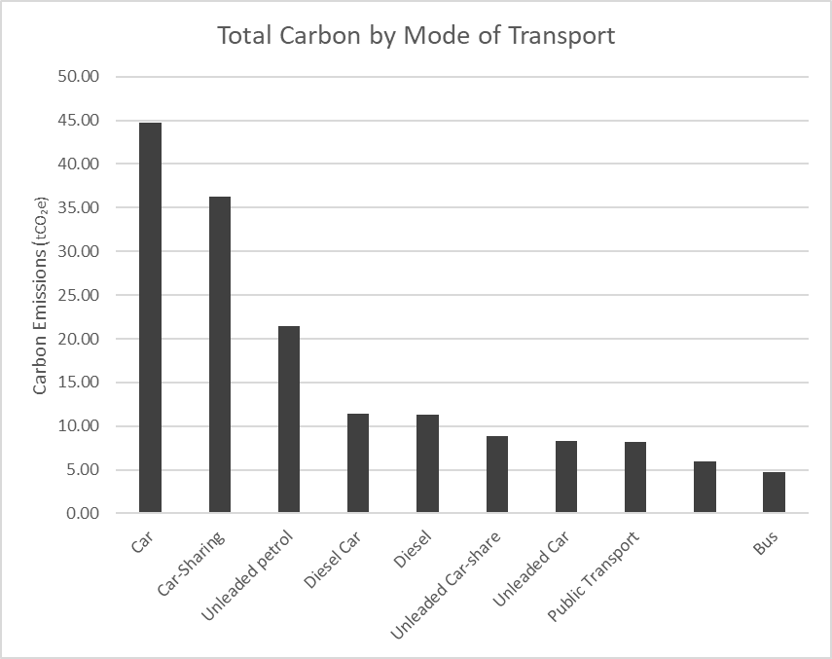

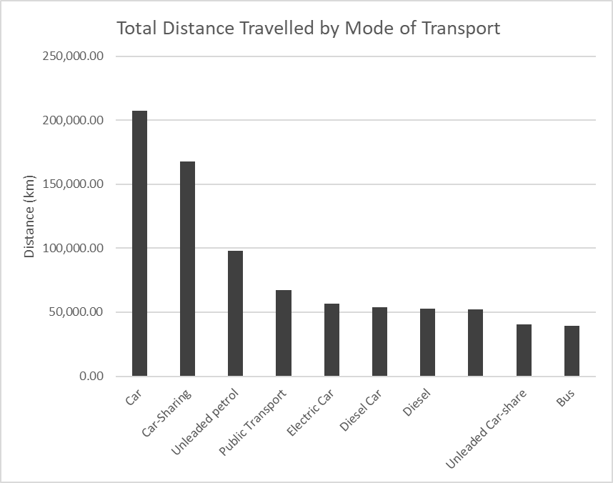

## Appendix E: Transport Mode Patterns in Geographical Data

* Commuters who use a car cover a wide range of postcodes across many different regions. As the car is the most convenient and able to travel freely, there is no discernible pattern in the distribution that is specific to car-users.
* No employees live to the east, with the biggest clusters of employees being north and south of ACS’ logistics centre. The rest of the employees are mostly spread out towards the West and around Glasgow
* Some commuters travel from remote areas (including the outliers at G65 (far north) and G22 (far west). These employees are very unlikely to have any satisfactory public transport alternative.
* Despite living close to ACS or in other urban areas with good transport links (such as G11 and G23) many employees still use the car.
* Bus users are generally located near to ACS (ML1).
* The sole train user lives near the city centre suggesting that travelling by train is not suitable for most employees.

## Appendix F-1: Table of Notes for Scoring Alternatives



Descriptions were converted to numerical values (these scores were plugged into the bisection charts to reach the true scores)

## Appendix F-2: Table of Linear Scores



## Appendix F-3: Swing-Weights Table

To weight the criteria, a Swing-Weight table is used. This facilitates a heuristic to determine relative weights for each criteria. The decision-maker was asked to weight the ‘swing’ or movement from the worst performing to the best performing performance of alternatives in any one criteria in comparison to that of other criteria. The arbitrary weight of 100 was given to financial cost to serve as a marker from which the other weights can be decided. These weights are then normalised to add up to one.



Table : Swing-Weight Table to Help the Decision-Maker in Deciding on Weights for each Criterion

## Appendix F-4: Table of Scores and Weights



## Appendix G: Bisection Curves for each Criterion

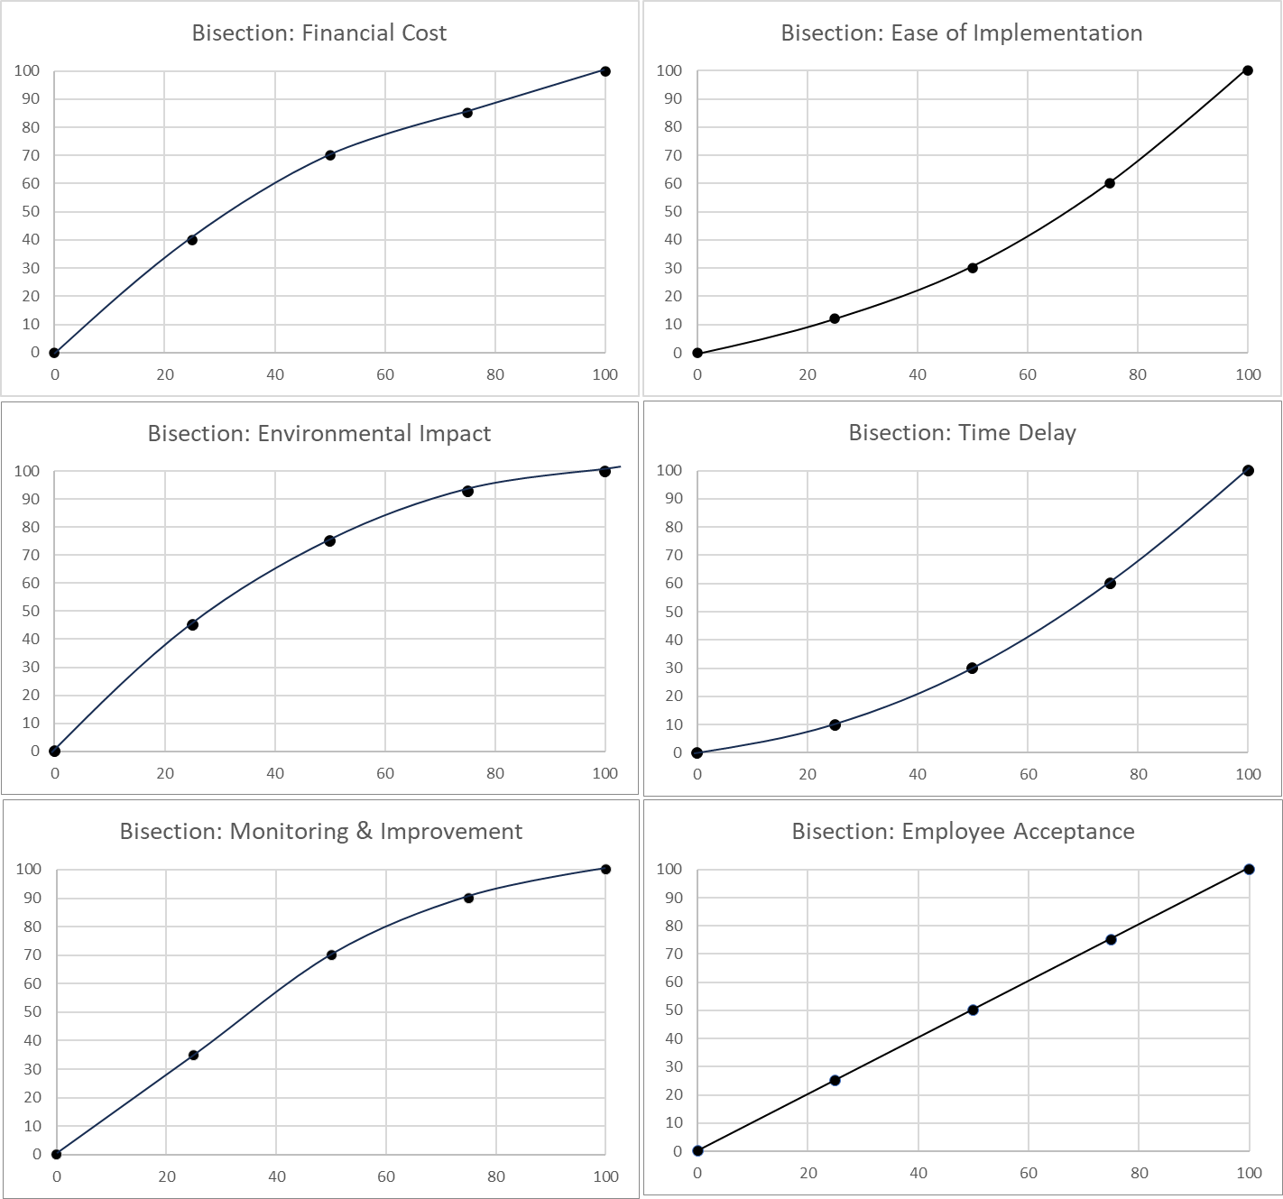

1. (B Corporation, 2024)
2. (from data provided by ACS Clothing)
3. tonnes of carbon dioxide equivalent
4. (B Corporation, 2024)
5. measured in kg of CO2
6. up from 82.46% in 2022
7. (University of Strathclyde, 2024)
8. NB// only shows engagement with the decision-maker that was for the explicit purpose of completing a section in the MCDA model.
9. Criteria, Alternatives, Uncertainties, Stakeholders, External factors; a framework for problem structuring
10. A data visualization software
11. collected March 2024
12. taken from surveyed commuter data provided by ACS
13. (Drach, 2024)
14. (Kahneman, 1993)
15. See Appendix F-1 to see a ‘table of notes’, which were used to develop this table
16. (Wright, 2023)